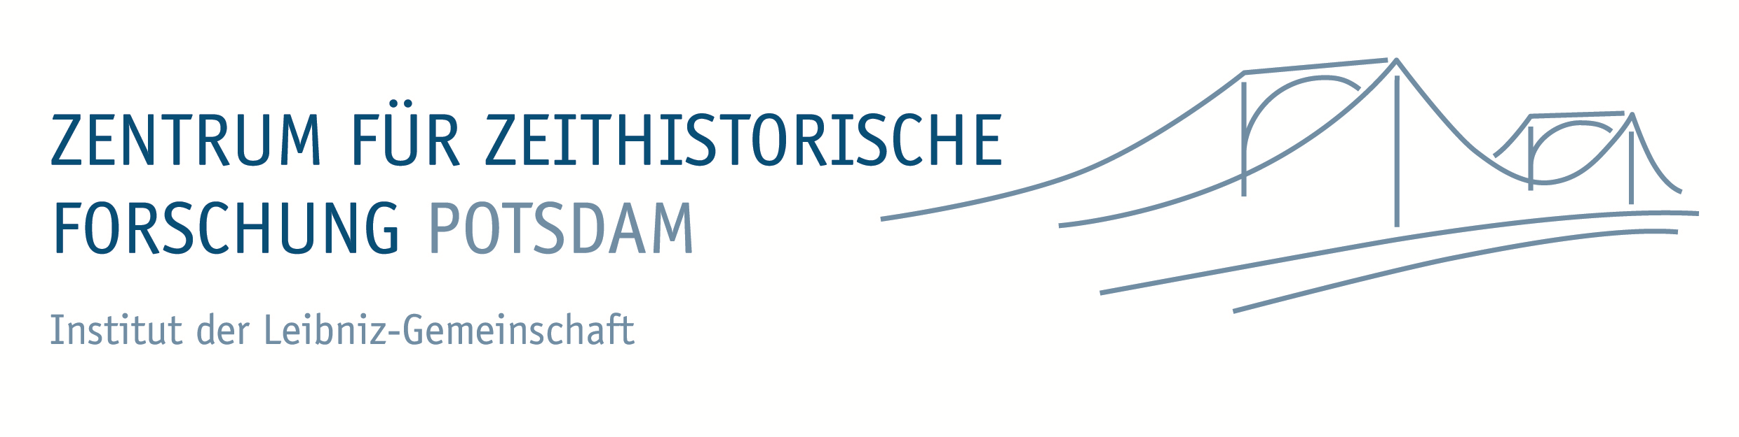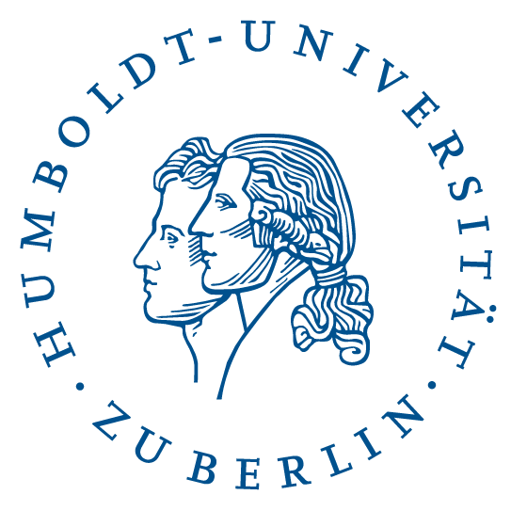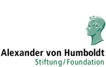

International Conference
Between Education, Commerce and Adventure
Tourist experience in Europe since the Interwar Period
Potsdam, 19-20 September 2013

Over the course of the twentieth century, tourism in Europe and North America experienced a veritable earthquake: it ceased to be confined to the upper and middle classes and became increasingly accessible to the working class. Mass tourism took on many forms, among which commercial tourism featured prominently. However, we wish to concentrate on Europe, since it was a testing field of numerous seemingly antagonistic models of mass tourism that have emerged since the 1930s: apart from commercial tourism, social tourism undertaken by non-profit enterprises and state-sponsored tourism in Nazi Germany as well as in socialist European countries. The conference is going to revolve around two issues. In order to better illuminate the diversity of tourist experience, it seeks to critically investigate the argument of the prevalence of commercial tourism; thus, it intends to further scrutinize interconnections among the abovementioned and seemingly competing tourist models. Moreover, it aims to help rethread the scholarly analysis of a plethora of profound economic, social, cultural and political transformations that shaped Europe in the 20th century through the lens of mass tourism. We are going to concentrate on mass consumption, the unfolding of Cold War, migration and the emergence of youth cultures. The conference languages are English and German.

Conveners: Priv.- Doz. Dr. Maren Möhring (Potsdam), Prof. Dr. Thomas Mergel (Berlin), Nikolaos Papadogiannis PhD (Berlin)

Conference venue:
Zentrum für Zeithistorische Forschung Potsdam
Großer Seminarraum
Am Neuen Markt 9d
14467 Potsdam

Contact Priv.-Doz. Dr. Maren Möhring (moehring@zzf-pdm.de)

Conference Program

Thursday, 19 September 2013

2.00 pm: Opening
Thomas Mergel (Berlin)
Frank Bösch (Potsdam)

2.15 – 2.30 pm: Introduction
Nikolaos Papadogiannis (Berlin)

2.30-2.45: Presentation of the Historical Archive of Tourism (HAT) in Berlin
Hasso Spode (Berlin)

2.45 – 4.30 pm: Panel I – Tourism and Dictatorship

Mark Keck-Szajbel (Frankfurt a. d. Oder/Berkeley): Poland as Sehnsuchtsort: East Germans in the People’s Republic in the 1970s
Martin Hurcombe (Bristol): Discovering Uomo Fascista: Political Tourism in Fascist Italy and the French Far Right
Comment: Mario Daniels (Hannover)

4.30 – 5.00 pm: Coffee break

5.00 – 7.00 pm: Panel II – Tourism and Youth in postwar Europe

Jürgen Mittag /Diana Wendland (Cologne): How adventurers become tourists – the role of alternative travel guides and tour operators in the course of standardisation of long-distance travelling
Christos Mais (Leiden): Mixing Revolution and Pleasure: Visiting Greece during the Junta (1967-1974)
Whitney Walton (West Lafayette): Study Abroad as Alternative Tourism: United States American Youth in France, 1945-1970s
Comment: Detlef Siegfried (Copenhagen)

8.00 pm: Dinner

Friday, 20 September 2013

9.00 – 10.30 am: Panel III – Tourism and Migration in Postwar Europe

Marcel Berlinghoff (Heidelberg): „Faux Touristes“? – Tourismus in europäischen Migrationsregimen seit den 1960er Jahren
Nikolaos Papadogiannis (Berlin): Migrants on vacation. The travel patterns of young Greek migrants residing in West Germany in the 1960s-1970s
Comment: Maren Möhring (Potsdam)

10.30 – 11.00 am: Coffee break

11.00 – 1.00 pm: Panel IV – Tourism, national/regional identities and social order in Central Europe before and after the Second World War

Gundolf Graml (Decatur): Tourism and “Nation-Building”: The Case of Austria, 1945-55
Adam Rosenbaum (Grand Junction): Beer, Castles, and Nazis? Tourism and the Construction of Authenticity in Postwar Bavaria
Andrew Behrendt (Pittsburgh): Distant Gazes at Nearby Places: The 'Vacation Movie' in Popular Austrian and Hungarian Interwar Cinema
Comment: Thomas Mergel (Berlin)

1.00 – 2.00 pm: Lunch

2.00 – 4.00 pm: Panel V – Tourism and Cold War borders

Sarah Hanke (Berlin): (K)eine Vergnügungsreise? West-Berlin-Tourismus zwischen politischem Anschauungsunterricht und „Weltstadt“-Erlebnis in den 1950er bis 1970er Jahren
Francesca Rolandi (Torino): Trst je nas! Yugoslav shopping tourism in Trieste
Benedikt Tondera (Hannover): ‚„The Soviet Gaze“? Überlegungen zu den Spezifika des sowjetischen Auslandstourismus
Comment: Hannes Grandits (Berlin)

4.00 – 4.30 pm: Concluding remarks and final discussion
Maren Möhring (Potsdam)

